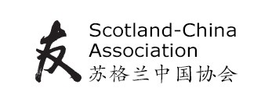
2020 Scottish Primary Schools Competition
For P5, P6 and P7
Design a kite
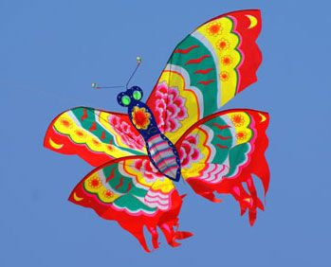

Kites have been made and flown all over the world for thousands of years, and are very popular in China. The aim of the competition is to inspire the creativity of Scottish primary school pupils and to encourage them to learn more about Scotland and China. Entries should explore ideas about Scotland and China through the design for a kite. We are working in partnership with RZSS Edinburgh Zoo, where the prize giving will be held.

Competition entries may be in any of the following forms:

1. Painting;
2. Drawing;
3. Craftwork (for example an actual kite);
4. Writing;
5. Photography;
6. Video/media/film (no more than 10 minutes long);
7. Embroidery/stitching/textile.

We welcome entries from individuals or groups in Primary 5, Primary 6 and Primary 7.

Pupils should be encouraged to use their imagination and explore ideas which demonstrate understanding of links between Scotland and China.

The prize giving will take place on Friday, 12 June 2020 at RZSS Edinburgh Zoo. Three prizes will be awarded in each grade and one school will be chosen as the overall winner of the Tom Murray Trophy. The prizes will be:

- For all those present on the day of the prize giving, free entry to Edinburgh Zoo for the prize-giving event. People are welcome, during the day, to visit the zoo park and the giant pandas. (Please note that it isn't possible to guarantee you will see the giant pandas on the day!)
- For the individual prize winners, a certificate and a gift.
- For the winning school, some of the gameboard quality RZSS Beyond the Panda resources to the value of £100. (Beyond the Panda resources are available to download and print from beyondthepanda.org.uk free but the prize will contain jigsaws or gameboard quality items, not within the free range.)
- The school’s name inscribed on the Tom Murray Trophy.
If you intend to enter, please email valerie.pellatt@ncl.ac.uk by 14th March.

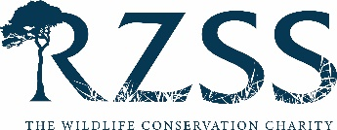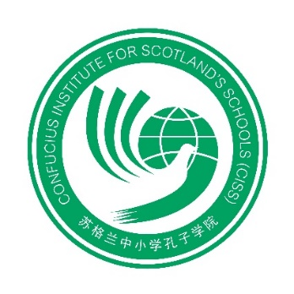
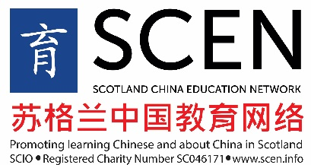

THE SCOTLAND–CHINA ASSOCIATION
2020 Scottish Primary Schools Competition
Design a kite
Entry form
School: ………………………………………………………………………………………………………………
Address: …………………………………………………………………………………………………………….
………………………………………………………………………………………………………………...
Post code: ………………………………………………..
Local Authority Area: ………………………………………………………………………………………...
Contact: …………………………………………………………………………………………………………….
Email: ………………………………………………………………………………………………………………..
Number of classes you wish to enter:
P5 ( )
P6 ( )
P7 ( )
Please send entries during the week beginning 11th May, and no later than Friday 15th May, with this completed entry form, to
SCA Schools Competition
Confucius Institute for Scotland
Abden House
1 Marchhall Crescent, Edinburgh EH16 5HP.

